OSSF Identification Using Remote Sensing and GIS
CMP Project #25-003-004-E697
Final Report
Ed Rhodes, Arifa Sultana, Sree Vidhya Kuduvaa Sankarbabu, Kenneth Ferrell, and Lucas Gregory
Texas Water Resources Institute
Texas A&M AgriLife Research
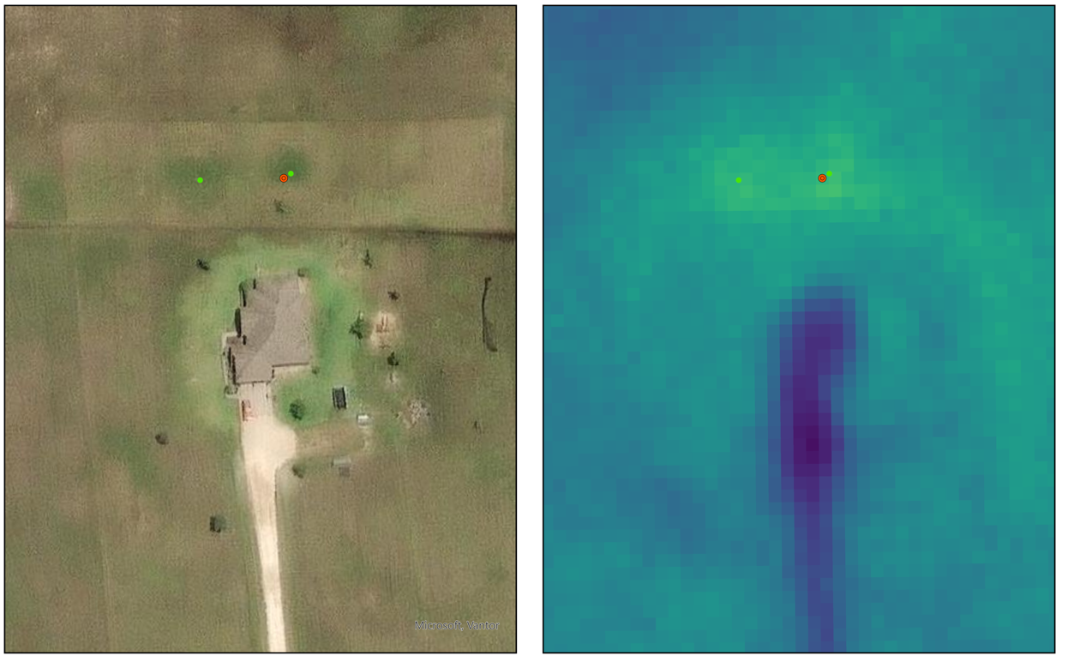
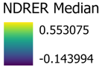
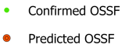





This report was funded in part by a Texas Coastal Management Program grant approved by the Texas Land Commissioner, providing financial assistance under the Coastal Zone Management Act of 1972, as amended, awarded by the National Oceanic and Atmospheric Administration (NOAA), Office for Coastal Management, pursuant to NOAA Award No. NA24NOSX419C0025. The views expressed herein are those of the author(s) and do not necessarily reflect the views of NOAA, the U.S. Department of Commerce, or any of their subagencies.

Abbreviations
CCN | Certificate of Convenience and Necessity
g | Grams
GIS | Geographical Information System
ft | Foot/Feet
LiDAR | Light Detection and Ranging
m | Meters
N | Nitrogen
NAIP | National Agricultural Imagery Program
NIR | Near infrared
NHD | National Hydrography Dataset
nm | nanometers
NPS | Nonpoint Source
OSSF | On-site sewage facility
P | Phosphorus
PFAS | Per and polyfluoroalkyl substances
PUCT | Public Utility Commission of Texas
RMSE | Root Mean Square Error
TAC | Texas Administrative Code
TXGLO | Texas General Land Office
TxGIO | Texas Geographic Information Office
TWDB | Texas Water Development Board
TWRI | Texas Water Resources Institute
USDA | United States Department of Agriculture
USEPA | United States Environmental Protection Agency
USGS | United States Geological Survey
WPP | Watershed Protection Plan

Table of Contents
Abbreviations 2
Executive Summary 4
Introduction 5
Methods 7
Location 7
Data 7
Analysis 9
Results 11
Discussion 12
Conclusion 14
References 14
Appendix 18

Executive Summary
On-site Sewage Facilities (OSSFs) have been known to be a nonpoint source of bacteria and nutrients in watersheds globally, yet records of where OSSFs are located are sparse, especially in the case of older systems. Over the years, many attempts have been made to estimate OSSF density in watersheds by counting rooftops in aerial imagery, or by filtering 911 addresses. In this project, we explore varying methods using remotely sensed satellite imagery indices (mathematical computations of different wavelengths) to locate known septic systems in a rural Texas coastal watershed. We discovered that the Normalized Difference Red Edge Red (NRDER) index consistently outperformed other indices in locating OSSFs. However, accuracy was still somewhat crude, with only 50% of predicted OSSF locations falling within 30m of a known OSSF site. Nevertheless, this research demonstrates the suitability of the NDRER in recognizing subtle differences in vegetation quality from water and nutrient outputs, and as remote sensing technologies improve, the applicability of this process may become more viable.

Introduction
Nonpoint source pollution (NPS) is a major contributor to surface water quality issues in the United States (Wagner et al., 2023). Nationally, nutrients such as phosphorus and nitrogen impair over 40% of US streams and rivers, while bacteria impairments account for over 20% (USEPA, 2024). These nonpoint source impairments become the driving force behind stakeholder-driven watershed protection plans (WPP) aimed at identifying and mitigating potential pollution sources. Often, one source of concern for nutrient and bacteria loadings in waterbodies is tied back to the usage of on-site sewage facilities (OSSFs), also known as septic systems. OSSFs are typically used in rural or outlying areas where municipal sewer systems are not available. Traditional OSSFs utilize a multi-step system where solids settle out of the wastewater and undergo partial breakdown through anaerobic digestion, before being gravity-fed into a leach field (Gregory et al., 2013; Lesikar, 1999). Under the right conditions, with an unsaturated soil profile, traditional septic systems can effectively handle effluent, resulting in the death of most fecal bacteria, and filtering and adsorption of nutrients, including denitrification (Withers et al., 2014). Aerobic units, on the other hand, include an aeration system to promote aerobic digestion, a disinfectant stage (typically chlorine), and a pump to distribute the effluent to a spray-field (Gregory et al., 2013; Lesikar, 2008). Aerobic units are more often used in areas where soil or spacing issues might preclude the use of traditional OSSF systems. When properly designed and maintained, OSSFs are an effective way to sanitize and dispose of wastewater.
It is estimated that nationally, between 10-20% of OSSF systems fail every year due to neglect or improper installation due to poor design or placement on incompatible soils (Beal et al., 2005; Lusk et al., 2017; Withers et al., 2014). Considering that approximately 25% of all homes in the USA, and one-third of all new construction (Lusk et al., 2017; Sowah et al., 2017), rely on OSSFs for wastewater management, failure of multiple OSSFs across a watershed can pose a serious water quality problem. This is especially a concern in coastal watersheds where shallow water tables, and saturated soil conditions may reduce effectiveness of OSSF systems, leading to pollution of ground- and surface waters (Gardner et al., 1997; Geary & Lucas, 2019; Gyimah et al., 2024; Withers et al., 2014).
The most commonly reported pollutants from OSSF systems include nutrients and bacteria. Per capita production of nitrogen (N) is approximately 11.2 g per day, 78% of which is generated from toilet use (Henze et al., 1997; Lusk et al., 2017), while per capita phosphorus (P) output is approximately 2.7g per day, primarily sourced from toilets and bath and laundry products (Lusk et al., 2017). In a properly functioning OSSF, fecal indicator bacteria levels can be reduced below detection limits within 10 m horizontally and 2 m vertically, due to the buildup of a subsurface biological layer (also knowns as a biofilm, or biomat) that restricts movement of microorganisms (Canter & Knox, 1986; Mbae et al., 2024). However, OSSFs that are discharging into chronically saturated soils, either due to septic failure (settling tank full, system too small to handle wastewater inflow, clogged or damaged pipes) or natural factors (soils too dense to allow proper drainage, water table to shallow, too close to a riparian area) can lead to fecal bacteria surviving and being transported through groundwater and surface runoff (Iverson et al., 2020; Lusk et al., 2017; Sowah et al., 2014; Sowah et al., 2017; Verhougstraete et al., 2015).
In addition to the concerns over bacterial and nutrient impairments from OSSFs, there is a growing body of research showing that OSSFs are reservoirs for emerging contaminants such as artificial sweeteners, personal care products, per and polyfluoroalkyl substances (PFAS), total organic carbon, and pharmaceuticals to name a few (Conn et al., 2010; Godfrey et al., 2007; Gyimah et al., 2024; Schaider et al., 2016; Spoelstra et al., 2017). PFAS, in particular, is slowly gaining relevance in the literature due to its widespread occurrence in everyday products, its toxicity to humans and animals, and its propensity to bioaccumulate in organisms (Berthold et al., 2023; Liu et al., 2024).
While the literature has focused on the effects that OSSFs can have on water quality, there have been few attempts to quantify the number and location of OSSFs within a watershed. Knowing the spatial distribution of OSSFs is critical to characterization of watersheds and the development of loading estimates. However, in Texas, there is no single repository for properties that have OSSF. Since 1989, all new OSSFs installed in Texas require a permit (TAC §285, 2026), however these records are kept at the local or county level, often in physical (rather than digital) repositories (Gregory et al., 2013). While some attempts have been made to digitize records in some localities, many rural areas are not represented, and pre-1989 OSSFs would not be represented in such datasets. Previous efforts to estimate OSSF locations have included using census data (He et al., 2011), manual counting of buildings from aerial photography (Gregory et al., 2013; Poiani et al., 1996), and the use of 911 address points (Gregory et al., 2013). However, recent advances in satellite remote sensing technologies (Rhodes et al., 2022) could potentially lead to more accurate estimates of OSSF placement.
Remote sensing, the science of observing an object or landscape via a device not in contact with the subject (i.e. a camera, digital sensor), has long been used to observe vegetation patterns, structure, and health since the launch of the Landsat 1 satellite in 1972 (NASA GSFC, 2020; Rhodes et al., 2022; Tueller, 1989). By understanding how different wavelengths of the electromagnetic spectrum are reflected or absorbed by plant structures and components (chlorophyll, healthy tissue, nitrogen, and water, among others), scientists have developed numerous metrics, or indices, to observe and quantify vegetative growth and health (Jensen, 2007). Vegetation greening and browning are easily observed through indices that utilize the red and near-infrared wavelengths (Talchabhadel et al., 2025). Since OSSFs are a constant source of water and nutrients, then, theoretically, it could be possible to locate and assess OSSF locations using remote sensing indices. Unfortunately, many of the available satellite platforms have coarse spatial and temporal resolutions, ranging from tens of meters to kilometers per pixel spatially, and days temporally (Rhodes et al., 2022).
Since 2016, however, higher spatial and temporal resolution satellite imagery have become available commercially. In this report, we explore the utility of higher resolution (3meter) satellite imagery-derived vegetation indices in estimating locations of OSSFs using geographical information systems (GIS) and remote sensing in a rural Gulf Coastal Plain watershed in Texas.

Methods

Location
Tres Palacios Creek watershed (Figure 1) spans 268 square miles through Wharton and Matagorda Counties on the Texas Gulf Coastal Plain, draining into the Matagorda Bay System (Schramm et al., 2017). Soils in the watershed are predominantly clayey, with slow infiltration, receiving about 41 inches of mean annual rainfall (Schramm et al., 2017). Elevation ranges from sea level to 115 feet above sea level (Schramm et al., 2017). In 2017 a stakeholder-driven watershed protection plan was developed to address concerns over elevated fecal bacteria levels, and depressed dissolved oxygen levels (Schramm et al., 2017). Land use is predominantly agricultural (cropland and hay/pasture) with less than 10% tree cover (USGS, 2024). These factors make this watershed an ideal case study in the use of a remote sensing approach to locating OSSFs.

Data

Vegetation Indices
To calculate the various vegetation indices used in this project, we utilized PlanetScope SuperDove imagery from Planet Labs (Planet Labs, 2026). PlanetScope imagery records data daily at a 3-meter (9.84 ft) resolution across eight “bands” (wavelengths), as shown in Appendix Table A-1. Planet Labs SuperDove is a commercial product; however, they offer limited free access for research and educational purposes. We attempted to download at least one cloud-free image per month from January 2021 through December 2025 and were able to gather 52 unique dates. From these 52 dates, eleven different vegetation indices were calculated for each date (Appendix Table A-2), focusing on indices that have been shown in the literature to have sensitivity to chlorophyll, greenness, nitrogen, and/or moisture.
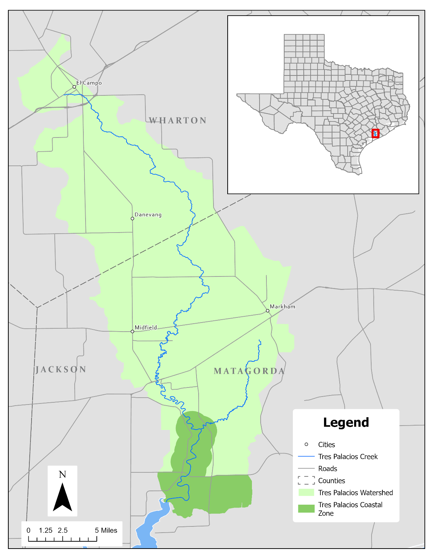
Figure 1: Tres Palacios Creek Watershed and Coastal Zone

Other Geospatial Data
Our workflow included several other geospatial datasets (Appendix Table A-3). These included building footprints from the Texas Water Development Board (TWDB) and waterbodies from the National Hydrography Dataset (NHD). From the Texas Geographic Information Office (TxGIO), we acquired United States Geological Survey (USGS) Light Detection and Ranging (LiDAR) data, United States Department of Agriculture (USDA) National Agricultural Imagery Program (NAIP) aerial imagery, land parcel boundaries and 911 address points. Certificate of Convenience and Necessity (CCN) boundaries were acquired from the Public Utility Commission of Texas (PUCT). Finally, we used the Tres Palacios Creek Watershed boundary, as developed in the 2017 WPP published by the Texas Water Resources Institute (TWRI), and the Tres Palacios Coastal Zone boundary provided by the Texas General Land Office (TXGLO). In addition to these existing datasets, a validation dataset of 120 known OSSF field locations was created through visual inspection of aerial imagery in Google Earth. Known septic locations were identified by observation of parallel lines typical of a conventional leach field piping, or rows of green circles (sprinklers) that are typical with aerated systems.

Analysis

Manual Workflow
To provide a baseline against a “business as usual” method, we conducted a manual estimate of OSSFs within the watershed by observing within the GIS program ArcGIS Pro. 911 address points were overlain over USDA NAIP imagery, and each point was assessed manually, and a judgement call was made as to whether the structure likely supported an OSSF. Structures such as homes and businesses that existed outside of a CCN area, were assumed to have an OSSF, while 911 addresses on barns, toolsheds, and other usages (e.g., agricultural) where excluded (Gregory et al., 2013).

GIS Workflow
To begin, we developed a spatial mask (data omission area) to exclude areas where an OSSF should not be by combining a number of shapefile polygon layers into a single mask file. We first created a woody plant cover layer using 2018 and 2019 LiDAR data for Matagorda and Wharton Counties, respectively, downloaded from TxGIO (USGS, 2018, 2019), masking out anything greater than or equal to 5 ft (1.5m) in height. Then, all creeks and rivers were buffered 50 feet, with this buffer added to the mask. Next, all waterbodies (lakes/ponds) and buildings were also added to the mask. Finally, all areas receiving sewer service under a Certificate of Convenience (CCN) were also added to the mask.
Following mask creation, the 11 vegetation indices were calculated following equations shown in Appendix Table A-2, using raster algebra in ArcGIS Pro v3.4 (ESRI, 2025). Next, a Python script was created using the ArcPy package for ArcGIS Pro that followed a multistep process (Figure 2) by first defining an OSSF search zone by filtering out all the buildings in the watershed greater than 800 square feet in area. This removes most small sheds and outbuildings, while keeping anything larger than a single wide mobile home. Next, we selected only the land parcels greater than or equal to 2,430 square feet where these structures were located. Next, we established an OSSF search zone in each parcel by creating a donut buffer around the structures that extends from 50 to 350 ft from the buildings. This search zone was then clipped with the exclusion mask to remove trees, waterbodies, structures, and CCN service areas. This final clipped area became the focus of our analysis.
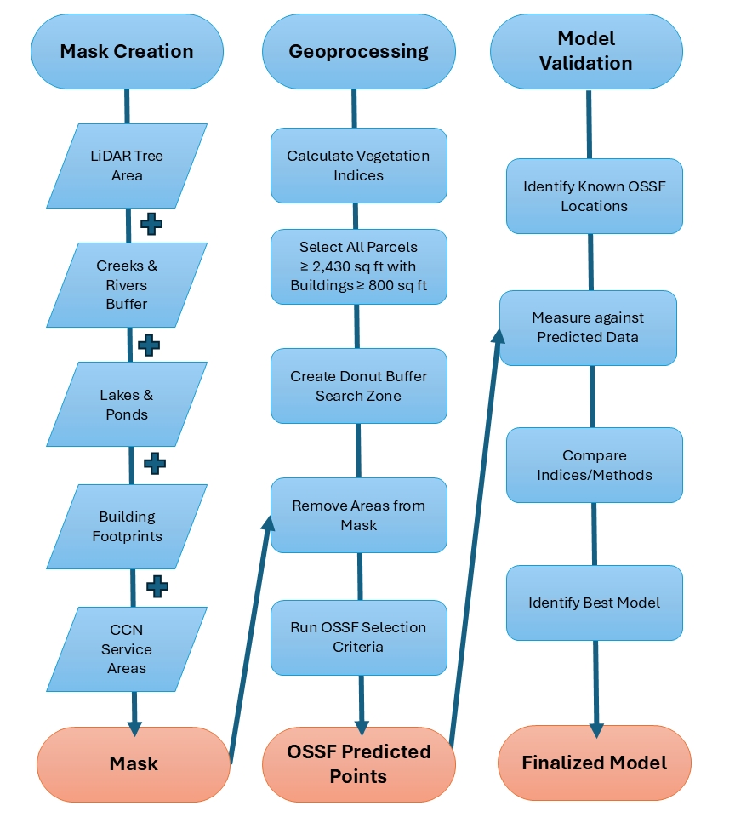
Figure 2: Geospatial Analysis Workflow
Since vegetation responses to climate, moisture, and nutrients can vary throughout the year, we explored different ways of processing and analyzing the indices from the 52 dates from 2021-2025. The first method, denoted as “All-date Pixel” selected a point from each parcel search zone that was closest to the global (i.e., watershed-wide) mean value. The second method, “February All Pixel” was similar, but only focused on the 5-yr February global mean value. February was singled out as most perennial forage and lawn grasses (e.g., bermudagrass) in this region are dormant/dead, there is little lawn irrigation, which may provide good contrast to cool-season vegetation growing over watered OSSF drainage areas. In addition to measuring the mean, we also conducted analysis using the median for all dates (Local Pixel) and February (February Local Pixel) at the parcel level.
Next, we conducted a hotspot analysis using the Getis-Ord Gi* method for the 5-year mean (All-Date Hotspot) and February mean (February Hotspot). The Getis-Ord Gi* (pronounced gee-eye-star) is a statistical method used to locate clusters of values that are either higher (hot spots) or lower (cold spots) than the surrounding areas (Getis & Ord, 1992).
Finally, we used time across the dataset (2021-2025) as a variable, that we called the “Temporal Persistence” method. Here, we ranked all index pixels per parcel, counting the number of times that each pixel was in the top 10% (wettest) of the parcel, with the idea an OSSF drainage area should be among the consistently wettest areas of the yard. By looking at percentages individually on each image date, this method allows each date to not be affected by climatic conditions from dry or wet periods.

Accuracy Assessment
Accuracy of each method was assessed with the 120 validation points by measuring the distance of each validation point to its corresponding predicted point in each parcel. The minimum, maximum, mean, median and root mean square error (RMSE) were calculated to evaluate the overall accuracy of each method. The RMSE is a directionless measure of the magnitude of error, calculated by taking the average of the squared residuals (errors) (Anderson et al., 2015). In this way, more weight is placed on large errors, therefore a high RMSE is indicative of large errors in the dataset (Anderson et al., 2015).

Results

Manual Workflow
The manual desktop GIS method produced 2,576 potential OSSFs. No accuracy assessments are available, since this method does not identify OSSF field locations, only buildings that potentially have OSSFs.

GIS Workflow
Accuracy measurements for all remote sensing methods are found in Appendix Table A-4. Accuracy among the various indices and methods varied wildly, from near “bullseyes” (<5 m) to hundreds of meters, with median values ranging from 27m to over 80 m. Our spatial filtering of buildings and parcels led to the creation of 2,516 donut search zones, with different methods extracting different total potential OSSF locations. However, one index consistently performed better than all the others, the Normalized Difference Red Edge Red (NDRER) index. The NDRER seemed to do particularly well with the All-Date Hotspot analysis, with a minimum value of 0.83 meters and a median of 27.35 meters. Nevertheless, despite NDRER having the best “bullseye” rate (< 5m) among all indices in the hotspot analysis, it was still very low at 2.7%.
Considering the performance of NDRER against all other indices, we decided to run the Temporal Persistence method with NDRER only, achieving a minimum value of 0.43 meters, a median of 24.04 meters, a 15% “bullseye” rate (<5m), and over 50% of the points falling within 30 meters of an actual OSSF (Appendix Table A-4).

Manual vs. GIS Workflow
Both the manual and GIS workflow produced similar numbers of estimated OSSFs across the entire watershed, as well as the coastal zone. The Manual workflow found 2,576 potential OSSFs across the entire watershed, while the final GIS “Persistence” Method tallied 2,500 potential OSSFs. Within the coastal zone boundary, the manual method identified 303 potential OSSFs, while the GIS workflow identified 317. Considering just search areas (“donuts”) created by the model, there were 2,516 for the entire Tres Palacios Watershed, and 323 for the coastal zone.

Discussion
In this project, we explored the potential of using a GIS and Remote Sensing approach to identifying OSSF locations within a rural coastal watershed. One index in particular, the Normalized Difference Red Edge Red index, was consistently near the top of every iteration of our model, performing particularly well in the hotspot and temporal persistence methods. The inclusion of the red edge band in the analysis seems to give this index an edge against all the other indices. The red edge wavelength represents a steep reflectance transition between red and near-infrared (NIR) on the electromagnetic spectrum (Moriarty et al., 2019), where red light is highly absorbed by plant tissue, and NIR is highly reflective. Since red edge represents the transition between absorption and reflectance, minute changes in chlorophyll content can drastically affect the reflectance of red-edge (Doneus et al., 2014; Verhoeven & Doneus, 2011), making it an ideal metric for separating lush vegetation that is high in moisture and nutrients against rainfed or poorly fertilized plants.
While this research is very promising (locating 61 out of 120 OSSFs within 30m), there is still some fine tuning needed to make this process applicable on a larger scale. Something that we noticed while validating the data, is that parcel size and tree cover appeared to influence the accuracy of our predictions. To quantify this, we analyzed the median prediction error for various parcel sizes (Appendix Table A-5) and confirmed our suspicions. We had the highest OSSF prediction accuracies on parcels that were less than 0.5 acres (75% within 30m) and between 0.5-1acres (100% within 30m). As parcel size increases over 1 acre, the model accuracy drops drastically (Appendix Table A-5).
Our other issue involves tree cover. From our LiDAR analysis, the Tres Palacios watershed only has about 9.8% total tree cover, however, a large portion of those trees occur around homes. To compound the issue, many of the trees around homes appear to be Live Oaks and other evergreen species that are vegetated year-round. Due to their extensive root systems (vertical and horizontal) that allow them to tap into water resources over a large area, this causes issues when using vegetation indices to look for vegetation anomalies. These trees can dominate the extreme “lushness” of the metrics being used to find OSSFs. This is why LiDAR data was adopted to mask out (exclude) woody vegetation. Unfortunately, this can lead to other issues as well. For one, some septic systems may be partially or wholly obscured by woody vegetation. This is not an ideal placement, as tree roots can damage OSSF infrastructure, but it is a reality that cannot be corrected for in the model. Therefore, masking out trees in some cases will lead to the next greenest grassy location to be chosen by the model. Secondly, the current publicly available LiDAR data for this region is from 2018 (Wharton County) and 2019 (Matagorda County), which are now 8 and 7 years old, respectively. Continued tree canopy growth, compounded with natural errors that may be in the data, leads to some of the tree masks not quite matching up with the current extent of the woody cover (Figure 3). This can leave slivers of woody vegetation unmasked, which then get chosen by the model as a potential septic location.
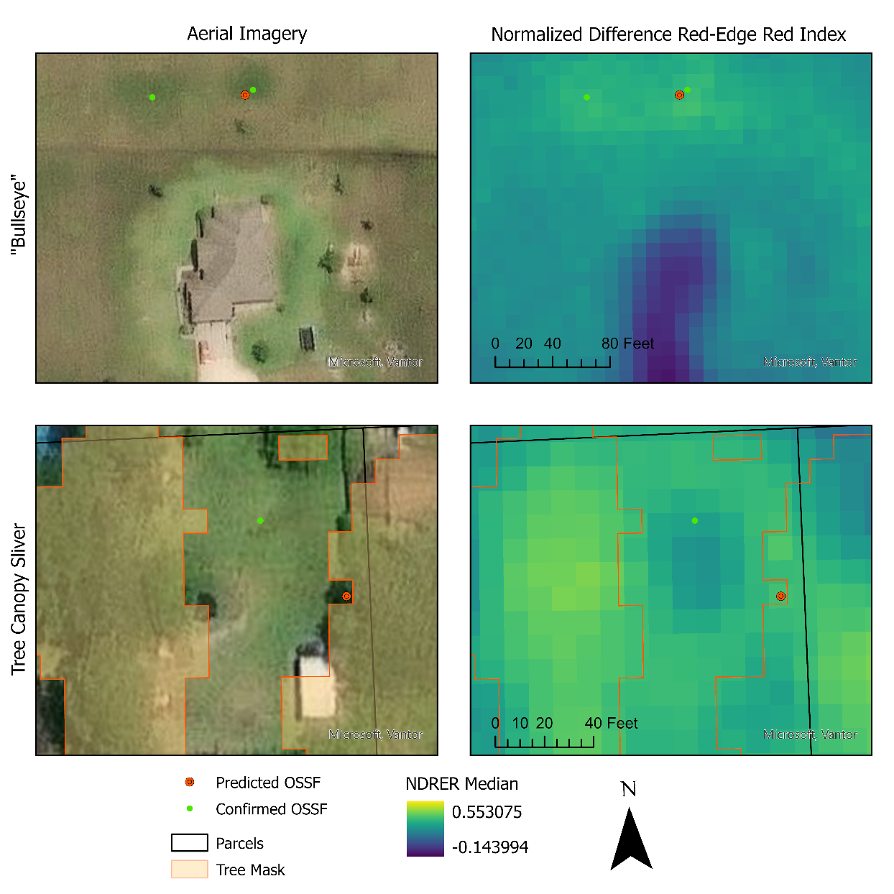
Figure 3: Open versus Wooded Properties. Imperfections in tree masks can cause misidentification of OSSFs.
One thing that is encouraging is that the final GIS persistence method closely matched the total number of OSSFs identified through the manual method, differing only by 2.9%. It should be noted that although the manual method is well supported in the literature, it is both A) time consuming, and B) subjective. Despite the spatial differences between the manual method identifying potential buildings where OSSFs may reside versus the GIS persistence method trying to locate actual discharge fields, both methods produce almost identical heatmaps of OSSF density at the watershed scale (Appendix Figure A-1). While the varying GIS methods evaluated varied greatly in their positional accuracy at the parcel level, they all had a common feature: the search donuts created around the filtered buildings and parcels. In this respect, the donut search zones, which total 2,516, represent a 2.4% difference from the manual method. Therefore, if a rough estimate of OSSFs is all that are needed, then filtering parcels and building footprints provides a rapid, and repeatable way to estimate OSSF density in a watershed that could be done in just a few minutes with ArcGIS or free programs such as QGIS.

Conclusion
In this study, we investigated 11 different vegetation indices and 7 processes to identify OSSFs in a rural Texas Coastal watershed. The Normalized Difference Red Edge Red (NDRER) index showed the most promise across every process. Our final, Temporal Persistence-based method had the highest accuracies, with a 15% “bullseye” rate, and identifying 50% of OSSFs within 30m. We had the greatest accuracy on parcels with fewer trees and less than 1 acre in size. As remote sensing satellite technology continues to mature, with higher resolution data becoming increasingly prominent, this project provides a solid baseline to build upon. While automated scripting of this process might not fully capture the OSSF distribution of an entire watershed, this process yielded the best overall index for identifying OSSFs, and may prove useful for manual, human-based observations on a per-parcel basis. Likewise, the NDRER may have other applications such as locating leaking water infrastructure along known conveyance lines.

References
Anderson, M. P., Woessner, W. W., & Hunt, R. J. (2015). Applied groundwater modeling: simulation of flow and advective transport. Academic press.
Beal, C., Gardner, E., & Menzies, N. (2005). Process, performance, and pollution potential: A review of septic tank–soil absorption systems. Soil Research, 43(7), 781-802.
Berthold, T. A., McCrary, A., Devilleneuve, S., & Schramm, M. (2023). Let’s talk about PFAS: Inconsistent public awareness about PFAS and its sources in the United States. PloS one, 18(11), e0294134.
Canter, L. W., & Knox, R. C. (1986). Septic tank system effects on ground water quality, Second Edition. Routledge.
Conn, K. E., Siegrist, R. L., Barber, L. B., & Meyer, M. T. (2010). Fate of trace organic compounds during vadose zone soil treatment in an onsite wastewater system. Environmental toxicology and chemistry, 29(2), 285-293.
Doneus, M., Verhoeven, G., Atzberger, C., Wess, M., & Ruš, M. (2014). New ways to extract archaeological information from hyperspectral pixels. Journal of Archaeological Science, 52, 84-96.
ESRI. (2025). ArcGIS Pro. In (Version 3.4) Environmental Systems Research Institute.
Gardner, T., Geary, P., & Gordon, I. (1997). Ecological sustainability and on-site effluent treatment systems. Australian journal of environmental management, 4(2), 144-156.
Geary, P., & Lucas, S. (2019). Contamination of estuaries from failing septic tank systems: difficulties in scaling up from monitored individual systems to cumulative impact. Environmental Science and Pollution Research, 26(3), 2132-2144.
Getis, A., & Ord, J. K. (1992). The analysis of spatial association by use of distance statistics. Geographical analysis, 24(3), 189-206.
Godfrey, E., Woessner, W. W., & Benotti, M. J. (2007). Pharmaceuticals in on‐site sewage effluent and ground water, western Montana. Groundwater, 45(3), 263-271.
Gregory, L., Blumenthal, B., Wagner, K., Borel, K., & Karthikeyan, R. (2013). Estimating on-site sewage facility density and distribution using geo-spatial analyses. Journal of Natural and Environmental Sciences, 4(1), 14-21.
Gyimah, R., Lebu, S., Owusu-Frimpong, I., Semiyaga, S., Salzberg, A., & Manga, M. (2024). Effluents from septic systems and impact on groundwater contamination: a systematic review. Environmental Science and Pollution Research, 31(54), 62655-62675.
He, J., Dougherty, M., Zellmer, R., & Martin, G. (2011). Assessing the status of onsite wastewater treatment systems in the Alabama Black Belt soil area. Environmental Engineering Science, 28(10), 693-699.
Henze, M., Harremoes, P., Arvin, E., & la Cour Jansen, J. (1997). Wastewater treatment. Biological and chemical processes; 2. rev.
Iverson, G., Sanderford, C., Humphrey Jr, C. P., Etheridge, J. R., & Kelley, T. (2020). Fecal indicator bacteria transport from watersheds with differing wastewater technologies and septic system densities. Applied Sciences, 10(18), 6525.
Jensen, J. R. (2007). Remote sensing of the environment: an earth resource perspective, 2nd Edition. Prentice Hall Upper Saddle River, NJ.
Lesikar, B. (1999). On-Site Wastewater Treatment Systems: Conventional Septic Tank/Drain Field. https://ossf.tamu.edu/files/2023/01/L-5234-8.99-Conventional-septic-tank-drain-field.pdf
Lesikar, B. (2008). On-Site Wastewater Treatment Systems: Aerobic Treatment Unit. https://ossf.tamu.edu/files/2023/01/L-5302-9.08-Aerobic-Treatment-Unit.pdf
Liu, Y., Shields, M. R., Puthigai, S., Gregory, L. F., & Berthold, A. A. (2024). Distribution of Per‐and Polyfluoroalkyl Substances in the Rapidly Urbanizing Arroyo Colorado Watershed, Texas. Journal of Contemporary Water Research & Education, 180(1), 23-36.
Lusk, M. G., Toor, G. S., Yang, Y.-Y., Mechtensimer, S., De, M., & Obreza, T. A. (2017). A review of the fate and transport of nitrogen, phosphorus, pathogens, and trace organic chemicals in septic systems. Critical Reviews in Environmental Science and Technology, 47(7), 455-541.
Mbae, M., Hansen, P., Way, C., Mills, F., Willetts, J., Foster, T., & Evans, B. (2024). Onsite sanitation systems and contamination of groundwater: A systematic review of the evidence for risk using the source-pathway-receptor model. PLoS Water, 3(7), e0000167.
Moriarty, C., Cowley, D. C., Wade, T., & Nichol, C. J. (2019). Deploying multispectral remote sensing for multi‐temporal analysis of archaeological crop stress at Ravenshall, Fife, Scotland. Archaeological Prospection, 26(1), 33-46.
NASA GSFC. (2020). Landsat Science Webpage. Retrieved January 5, 2022 from https://landsat.gsfc.nasa.gov/
Planet Labs. (2026). PlanetScope Documentation. Retrieved September 8, 2026 from https://docs.planet.com/data/imagery/planetscope/
Poiani, K. A., Bedford, B. L., & Merrill, M. D. (1996). A GIS-based index for relating landscape characteristics to potential nitrogen leaching to wetlands. Landscape ecology, 11(4), 237-255.
Rhodes, E. C., Perotto-Baldivieso, H. L., Reeves, M. C., & Gonzalez, L. A. (2022). Perspectives on the Special Issue for Applications of Remote Sensing for Livestock and Grazingland Management. Remote Sensing, 14(8), 1882. https://www.mdpi.com/2072-4292/14/8/1882
Schaider, L. A., Ackerman, J. M., & Rudel, R. A. (2016). Septic systems as sources of organic wastewater compounds in domestic drinking water wells in a shallow sand and gravel aquifer. Science of the total Environment, 547, 470-481.
Schramm, M., Berthold, A., & Entwistle, C. (2017). Tres Palacios Creek Watershed Protection Plan. https://twri.tamu.edu/wp-content/uploads/2024/04/tr-500.pdf
Sowah, R., Zhang, H., Radcliffe, D., Bauske, E., & Habteselassie, M. (2014). Evaluating the influence of septic systems and watershed characteristics on stream faecal pollution in suburban watersheds in G eorgia, USA. Journal of applied microbiology, 117(5), 1500-1512.
Sowah, R. A., Habteselassie, M. Y., Radcliffe, D. E., Bauske, E., & Risse, M. (2017). Isolating the impact of septic systems on fecal pollution in streams of suburban watersheds in Georgia, United States. Water Research, 108, 330-338.
Spoelstra, J., Senger, N. D., & Schiff, S. L. (2017). Artificial sweeteners reveal septic system effluent in rural groundwater. Journal of Environmental Quality, 46(6), 1434-1443.
Texas Administrative Code §285, (2026). https://newtools.cira.state.tx.us/upload/page/0983/docs/LandDevAndEmerg/30%20TAC%20Chapter%20285.pdf
Talchabhadel, R., Rhodes, E. C., Palmate, S. S., & Kumar, S. (2025). Evaluating Vegetation Greening and Browning across the Rio Grande Basin. Earth Systems and Environment, 1-19.
Tueller, P. T. (1989). Remote sensing technology for rangeland management applications. Journal of Range Management, 42(6), 442-453.
USEPA. (2024). National Rivers and Streams Assessment: The Third Collaborative Survey. EPA 841-R-22-004. (Revised from December 2023.). https://riverstreamassessment.epa.gov/webreport
USGS. (2018). Lavaca & Wharton Counties Lidar, 2018-01-15 (https://data.geographic.texas.gov/collection/?c=642a83e0-c735-4ba6-a89c-85a723a1ad94
USGS. (2019). Matagorda Bay Lidar, 2019-01-29 (https://data.geographic.texas.gov/collection/?c=8774ed51-b633-4f03-85ca-94c311ee0a88
USGS. (2024). Annual National Land Cover (NLCD) Collection 1 Science Products: USGS Survey Data Release (https://doi.org/10.5066/P94UXNTS
Verhoeven, G., & Doneus, M. (2011). Balancing on the Borderline–a Low‐cost Approach to Visualize the Red‐edge Shift for the Benefit of Aerial Archaeology. Archaeological Prospection, 18(4), 267-278.
Verhougstraete, M. P., Martin, S. L., Kendall, A. D., Hyndman, D. W., & Rose, J. B. (2015). Linking fecal bacteria in rivers to landscape, geochemical, and hydrologic factors and sources at the basin scale. Proceedings of the National Academy of Sciences, 112(33), 10419-10424.
Wagner, K. L., Gregory, L., Gerlich, J. A., Rhodes, E. C., & deVilleneuve, S. (2023). Edge-of-Field Runoff Analysis following Grazing and Silvicultural Best Management Practices in Northeast Texas. Water, 15(20), 3537.
Withers, P. J., Jordan, P., May, L., Jarvie, H. P., & Deal, N. E. (2014). Do septic tank systems pose a hidden threat to water quality? Frontiers in Ecology and the Environment, 12(2), 123-130.

Appendix

Table A-1: PlanetScope SuperDove Imagery bands and wavelengths
Band | Name | Central Wavelength (nm)
1 | Coastal Blue | 443
2 | Blue | 490
3 | Green I | 531
4 | Green | 565
5 | Yellow | 610
6 | Red | 665
7 | Red Edge | 705
8 | Near-Infrared | 865

Table A-2: Remote Sensing Indices Used in this study.
Index | Full Name | Bands | Equation | Index Range | Primary Sensitivity
NDVI | Normalized Difference Vegetation Index | Red, NIR | $$\frac{(NIR-Red)}{(NIR+Red)}$$ | -1.0 to +1.0 | General greenness
NDRE | Normalized Difference Red Edge | Red Edge, NIR | $$\frac{(NIR-Red Edge)}{(NIR+Red Edge)}$$ | -1.0 to +1.0 | Chlorophyll
NDWI | Normalized Difference Water Index | Green, NIR | $$\frac{(Green-NIR)}{(Green+NIR)}$$ | -1.0 to +1.0 | Vegetation water content
GNDVI | Green Normalized Difference Vegetation Index | Green, NIR | $$\frac{(NIR-Green)}{(NIR+Green)}$$ | -1.0 to +1.0 | Chlorophyll, Nitrogen
PSRI | Plant Senescence Reflectance Index | Blue, Red, Red Edge | $$\frac{(Red-Blue)}{(Red Edge)}$$ | -1.0 to +1.0 | Senescence, plant stress
NDRER | Normalized Difference Red Edge Red | Red Edge, NIR | $$\frac{(Red Edge-Red)}{(Red Edge+Red)}$$ | -1.0 to +1.0 | Chlorophyll, plant vigor
SAVI | Soil-Adjusted Vegetation Index | Red, NIR | $$1.5*\left(\frac{(NIR-Red)}{(NIR+Red+0.5)}\right)$$ | -1.0 to +1.0 | Soil-corrected greenness
EVI2 | Two-Band Enhanced Vegetation Index | Red, NIR | $$2.5*\left(\frac{\left(NIR-Red\right)}{\left(NIR+\left(2.4*Red\right)+1\right)}\right)$$ | -1.0 to +1.0 | Greenness
CIre | Chlorophyll Index Red Edge | Red Edge, NIR | $$\left(\frac{NIR}{Red Edge}\right)-1$$ | -1.0 to +1.0 | Chlorophyll
CIg | Chlorophyll Index Green | Green, NIR | $$\left(\frac{NIR}{Green}\right)-1$$ | -1.0 to +1.0 | Chlorophyll
MTCI | MERIS Terrestrial Chlorophyll Index | Red, Red Edge, NIR | $$\frac{(NIR-Red Edge)}{(Red Edge-Red)}$$ | 0 to ∞ | Chlorophyll

Table A-3: Geospatial datasets used in this study
Data Type | Format | Source
Building Footprints | ESRI Polygon Shapefile | Texas Water Development Board
Waterbodies (Ponds/Lakes) | ESRI Polygon Shapefile | National Hydrography Dataset
Streams/Rivers | ESRI Polyline Shapefile | Texas Commission on Environmental Quality
911 Addresses | ESRI Point Shapefile | Texas Geographic Information Office
Certificate of Convenience and Necessity Boundaries | ESRI Polygon Shapefile | Public Utility Commission of Texas
Tres Palacios Creek Watershed Boundary | ESRI Polygon Shapefile | Texas Water Resources Institute
Tres Palacios Coastal Zone Boundary | ESRI Polygon Shapefile | Texas General Land Office
LiDAR Elevation | LiDAR Point Cloud | Texas Geographic Information Office
USDA NAIP Imagery | 60cm Raster | Texas Geographic Information Office

Table A-4: GIS Methods of OSSF identification and associated accuracy metrics
Method | Index | Matched | Min (m) | Max (m) | Mean (m) | Median (m) | RMSE (m) | ≤5m | ≤15m | ≤30m | Total Predicted Points
All-Date Pixel | NDVI | 119 | 6.46 | 245.74 | 67.1 | 55.48 | 79.23 | 0.00% | 2.50% | 10.10% | 2504
 | NDRE | 119 | 7.17 | 194.13 | 65.49 | 57.23 | 76.3 | 0.00% | 3.40% | 15.10% | 2504
 | NDWI | 119 | 7.11 | 224.04 | 65.4 | 59.04 | 76.75 | 0.00% | 3.40% | 16.80% | 2504
 | GNDVI | 119 | 7.11 | 224.04 | 65.4 | 59.04 | 76.75 | 0.00% | 3.40% | 16.80% | 2504
 | PSRI | 119 | 6.46 | 224.92 | 69.55 | 59.93 | 82.56 | 0.00% | 5.00% | 14.30% | 2504
 | NDRER | 118 | 5.07 | 167.45 | 63.66 | 59.57 | 72.43 | 0.00% | 4.20% | 14.40% | 2504
 | EVI2 | 119 | 6.46 | 205.06 | 63.5 | 58.06 | 73.75 | 0.00% | 3.40% | 15.10% | 2504
 | SAVI | 119 | 6.46 | 245.74 | 67.25 | 55.56 | 79.17 | 0.00% | 2.50% | 10.10% | 2504
 | CIre | 119 | 6.45 | 226.57 | 68.23 | 63 | 79.49 | 0.00% | 3.40% | 18.50% | 2504
 | CIg | 120 | 4.08 | 211.54 | 67.34 | 54.8 | 81.01 | 0.80% | 5.00% | 20.00% | 2504
 | MTCI | 120 | 7.21 | 202.21 | 61.3 | 58.12 | 71.63 | 0.00% | 4.20% | 25.00% | 2504
February All Pixel | NDVI | 119 | 13.15 | 170.28 | 68.04 | 56.62 | 77.3 | 0.00% | 2.50% | 11.80% | 2504
 | NDRE | 119 | 3.29 | 218.58 | 66.53 | 54.56 | 78.43 | 0.80% | 3.40% | 16.80% | 2504
 | NDWI | 119 | 7.17 | 193.6 | 65.7 | 62.17 | 75.15 | 0.00% | 5.00% | 12.60% | 2504
 | GNDVI | 119 | 7.17 | 193.6 | 65.7 | 62.17 | 75.15 | 0.00% | 5.00% | 12.60% | 2504
 | PSRI | 120 | 5.38 | 240.88 | 61.25 | 49.95 | 74.5 | 0.00% | 6.70% | 21.70% | 2504
 | NDRER | 119 | 6.46 | 216.61 | 65.93 | 54.5 | 78.5 | 0.00% | 6.70% | 17.60% | 2504
 | EVI2 | 120 | 11.73 | 245.05 | 65.31 | 57.24 | 77.88 | 0.00% | 0.80% | 16.70% | 2504
 | SAVI | 119 | 13.15 | 170.28 | 69.44 | 57.27 | 79.3 | 0.00% | 2.50% | 11.80% | 2504
 | CIre | 119 | 4.28 | 209.66 | 65.33 | 59.93 | 76.6 | 0.80% | 4.20% | 16.80% | 2504
 | CIg | 119 | 8.64 | 177.5 | 63.65 | 54.84 | 74.3 | 0.00% | 2.50% | 18.50% | 2504
 | MTCI | 120 | 1.7 | 247.07 | 66.52 | 55.55 | 78.5 | 0.80% | 4.20% | 13.30% | 2504
Local Pixel | NDVI | 120 | 1.82 | 227.27 | 56.86 | 48.21 | 70.61 | 5.80% | 13.30% | 31.70% | 2254
 | NDRE | 120 | 2.17 | 227.27 | 57.38 | 49.95 | 69.97 | 3.30% | 7.50% | 27.50% | 2254
 | NDWI | 120 | 3.88 | 212.18 | 71.31 | 64.16 | 81.73 | 0.80% | 2.50% | 8.30% | 2254
 | GNDVI | 120 | 2.56 | 227.27 | 60.01 | 50.05 | 74.59 | 2.50% | 11.70% | 30.80% | 2254
 | PSRI | 120 | 2.44 | 227.27 | 67.03 | 56.39 | 80.88 | 2.50% | 5.00% | 21.70% | 2254
 | NDRER | 120 | 1.05 | 227.27 | 50.61 | 32.82 | 69.71 | 8.30% | 26.70% | 46.70% | 2254
 | EVI2 | 120 | 1.82 | 227.27 | 55.36 | 45.82 | 68.75 | 5.80% | 13.30% | 33.30% | 2254
 | SAVI | 120 | 1.82 | 227.27 | 56.86 | 48.21 | 70.61 | 5.80% | 13.30% | 31.70% | 2254
 | CIre | 120 | 2.17 | 227.27 | 58.87 | 51.06 | 72.39 | 3.30% | 8.30% | 28.30% | 2254
 | CIg | 120 | 2.56 | 227.27 | 59.69 | 49.38 | 74.1 | 2.50% | 9.20% | 32.50% | 2254
 | MTCI | 120 | 3.75 | 211.77 | 71.13 | 63.29 | 81.14 | 1.70% | 1.70% | 11.70% | 2254
February Local Pixel | NDVI | 120 | 0.28 | 227.26 | 52.5 | 37.02 | 68.66 | 7.50% | 21.70% | 40.80% | 2253
 | NDRE | 120 | 0.69 | 225.69 | 53.72 | 40.34 | 67.3 | 3.30% | 15.00% | 35.80% | 2253
 | NDWI | 120 | 3.29 | 207.21 | 73.65 | 65.88 | 84.91 | 0.80% | 3.30% | 10.00% | 2253
 | GNDVI | 120 | 2.27 | 226.33 | 54.62 | 40.9 | 69.58 | 3.30% | 15.00% | 36.70% | 2253
 | PSRI | 120 | 2.45 | 215.75 | 66.7 | 51.53 | 83.26 | 2.50% | 10.80% | 26.70% | 2253
 | NDRER | 120 | 0.28 | 227.26 | 51.19 | 33.97 | 69.01 | 7.50% | 20.80% | 45.00% | 2253
 | EVI2 | 120 | 0.28 | 227.26 | 53.45 | 39.75 | 69.3 | 6.70% | 20.80% | 39.20% | 2253
 | SAVI | 120 | 0.28 | 227.26 | 52.5 | 37.02 | 68.66 | 7.50% | 21.70% | 40.80% | 2253
 | CIre | 120 | 0.69 | 226.33 | 54.08 | 40.34 | 68.22 | 3.30% | 15.00% | 34.20% | 2253
 | CIg | 120 | 2.56 | 226.33 | 54.68 | 40.9 | 70.54 | 4.20% | 15.80% | 37.50% | 2253
 | MTCI | 119 | 1.7 | 245.27 | 68.94 | 64.09 | 80.09 | 0.80% | 2.50% | 14.30% | 2253
All-Date Hotspot | NDVI | 113 | 1.72 | 220.06 | 50.35 | 30.93 | 67.35 | 0.90% | 17.70% | 49.60% | 2043
 | NDRE | 109 | 3.14 | 206.34 | 53.15 | 38.25 | 66.42 | 0.90% | 11.90% | 34.90% | 2120
 | NDWI | 79 | 6.46 | 194.02 | 79.66 | 72.28 | 86.89 | 0.00% | 2.50% | 2.50% | 822
 | GNDVI | 114 | 3.59 | 195.53 | 51.9 | 32.26 | 67.74 | 1.80% | 16.70% | 43.90% | 1909
 | PSRI | 82 | 11.45 | 185.83 | 79.57 | 74.38 | 89.77 | 0.00% | 4.90% | 12.20% | 712
 | NDRER | 113 | 0.83 | 227.88 | 47.07 | 27.35 | 66.26 | 2.70% | 23.90% | 55.80% | 1836
 | EVI2 | 111 | 1.36 | 222.65 | 50.04 | 30.93 | 67.25 | 1.80% | 17.10% | 49.50% | 1993
 | SAVI | 113 | 1.72 | 220.06 | 50.35 | 30.93 | 67.35 | 0.90% | 17.70% | 49.60% | 2043
 | CIre | 100 | 1.36 | 226.34 | 57.01 | 41.21 | 70.66 | 1.00% | 11.00% | 31.00% | 2039
 | CIg | 98 | 3.59 | 209.38 | 61.39 | 44.03 | 77.95 | 1.00% | 13.30% | 33.70% | 1772
 | MTCI | 82 | 4.35 | 134.48 | 65.14 | 64.13 | 71.24 | 1.20% | 4.90% | 9.80% | 1503
February Hotspot | NDVI | 116 | 3.59 | 228.27 | 52.49 | 29.76 | 71.98 | 2.60% | 16.40% | 50.00% | 2027
 | NDRE | 115 | 1.06 | 226.33 | 52.12 | 34.21 | 68.11 | 3.50% | 13.00% | 42.60% | 2063
 | NDWI | 81 | 6.45 | 191.89 | 83.05 | 75.81 | 91.29 | 0.00% | 3.70% | 3.70% | 844
 | GNDVI | 115 | 2.45 | 220.36 | 51.79 | 31.54 | 69.48 | 1.70% | 20.00% | 49.60% | 1892
 | PSRI | 81 | 7.83 | 209.91 | 83.46 | 66.71 | 96.08 | 0.00% | 4.90% | 12.30% | 760
 | NDRER | 116 | 0.81 | 228.27 | 54.62 | 31.29 | 74.16 | 3.40% | 17.20% | 49.10% | 1924
 | EVI2 | 116 | 2.52 | 228.27 | 54.37 | 30.17 | 73.9 | 2.60% | 13.80% | 50.00% | 2001
 | SAVI | 116 | 3.59 | 228.27 | 52.49 | 29.76 | 71.98 | 2.60% | 16.40% | 50.00% | 2027
 | CIre | 112 | 1.36 | 220.36 | 52.72 | 37.3 | 67.4 | 0.90% | 12.50% | 42.00% | 2012
 | CIg | 110 | 4.27 | 220.36 | 55.29 | 31.61 | 74.06 | 0.90% | 20.00% | 47.30% | 1802
 | MTCI | 44 | 6.45 | 138.23 | 72.23 | 69.12 | 79.83 | 0.00% | 6.80% | 11.40% | 519
Temporal Persistence | NDRER | 120 | 0.43 | 228.27 | 45.24 | 27.04 | 66.47 | 15.00% | 32.50% | 50.80% | 2500

Table A-5: Temporal Persistence model accuracy by parcel size
Parcel Size | Median Error | Percent within 30m
<0.5 acres | 24.3 m | 71%
0.5-1 acres | 14.0 m | 100%
1-2 acres | 25.6 m | 58%
2-5 acres | 23.8 m | 53%
5-10 acres | 86.0 m | 15%
>10 acres | 63.6 m | 35%

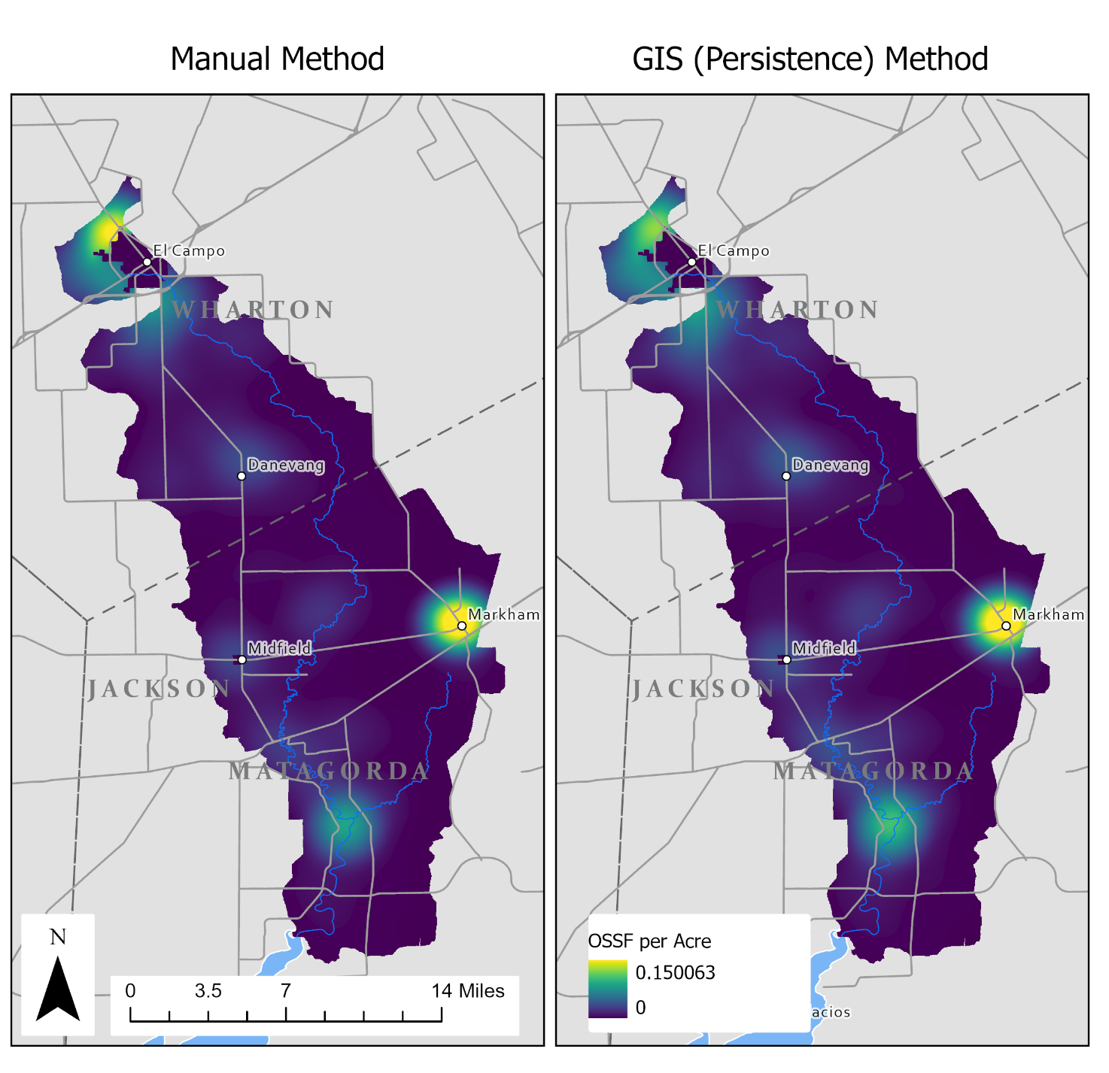
Figure A - 1: OSSF Density from the Manual Method and the GIS Persistence Method

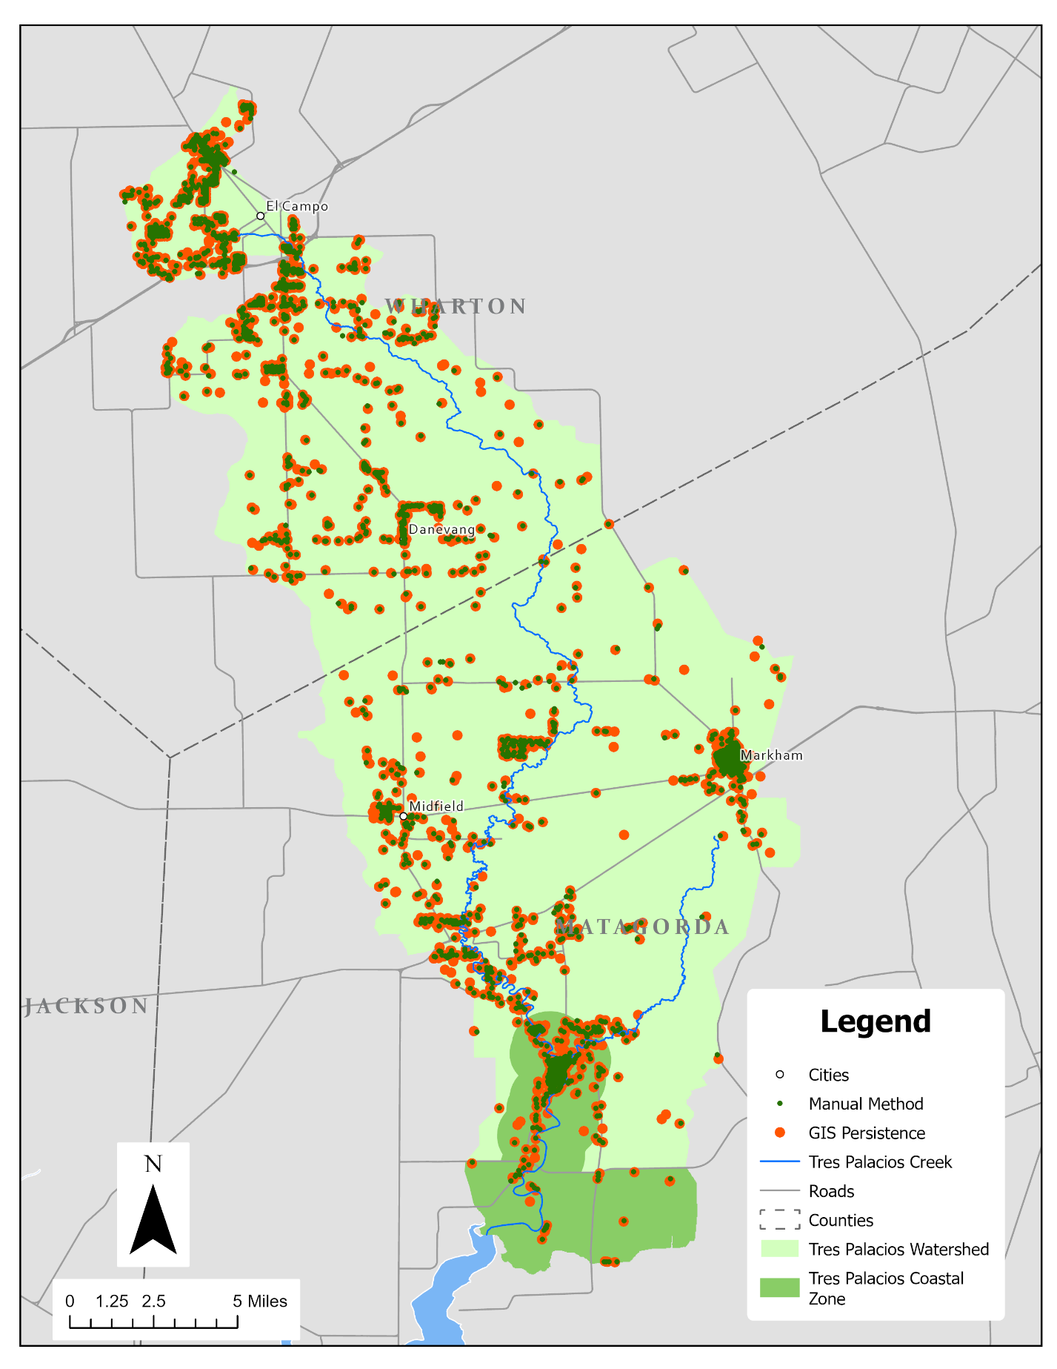
Figure A - 2: Distribution of Manual vs Predicted OSSFs

